1 Mile

City Limits

Sinclair Wash

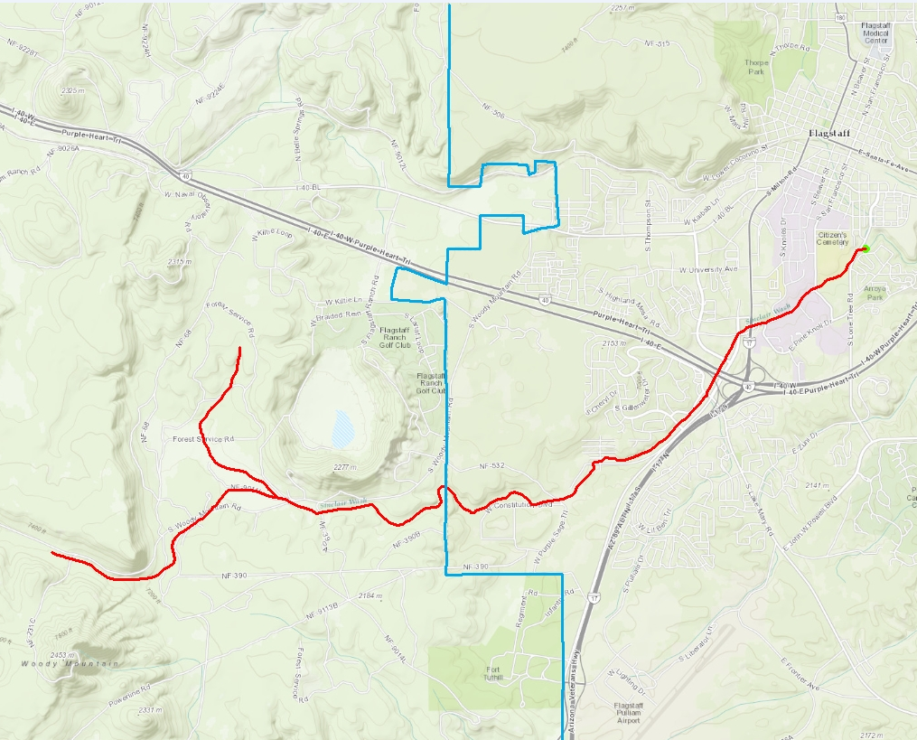

Walmart

S Lone Tree Road

Woody Mountain Road

N